McConnell, S. (1996). *Rapid Development: Taming Wild Software Schedules*. Microsoft Press.

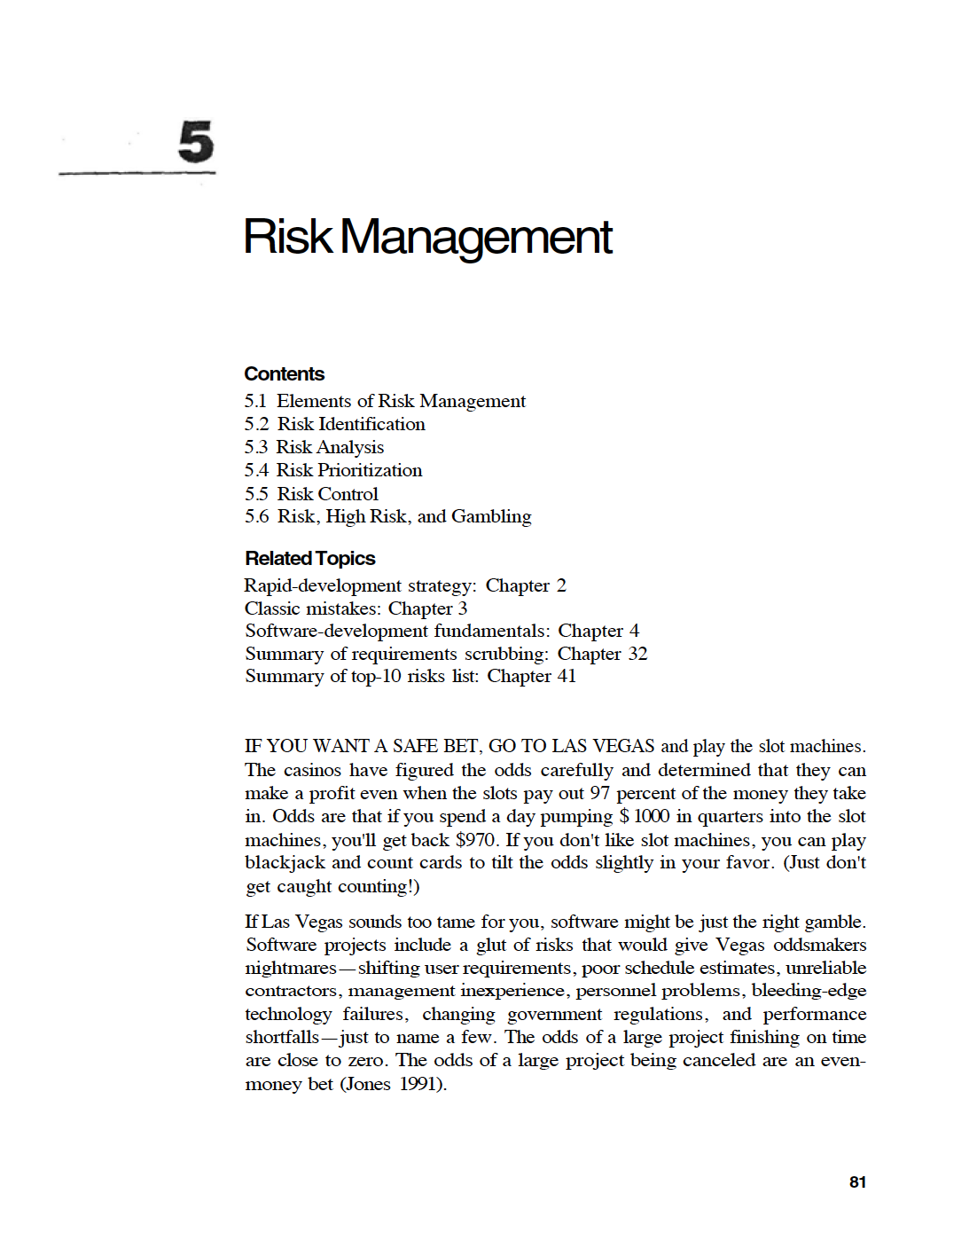

Sommerville, I. (2016). *Software Engineering* (10th ed.). Pearson Education Limited.

